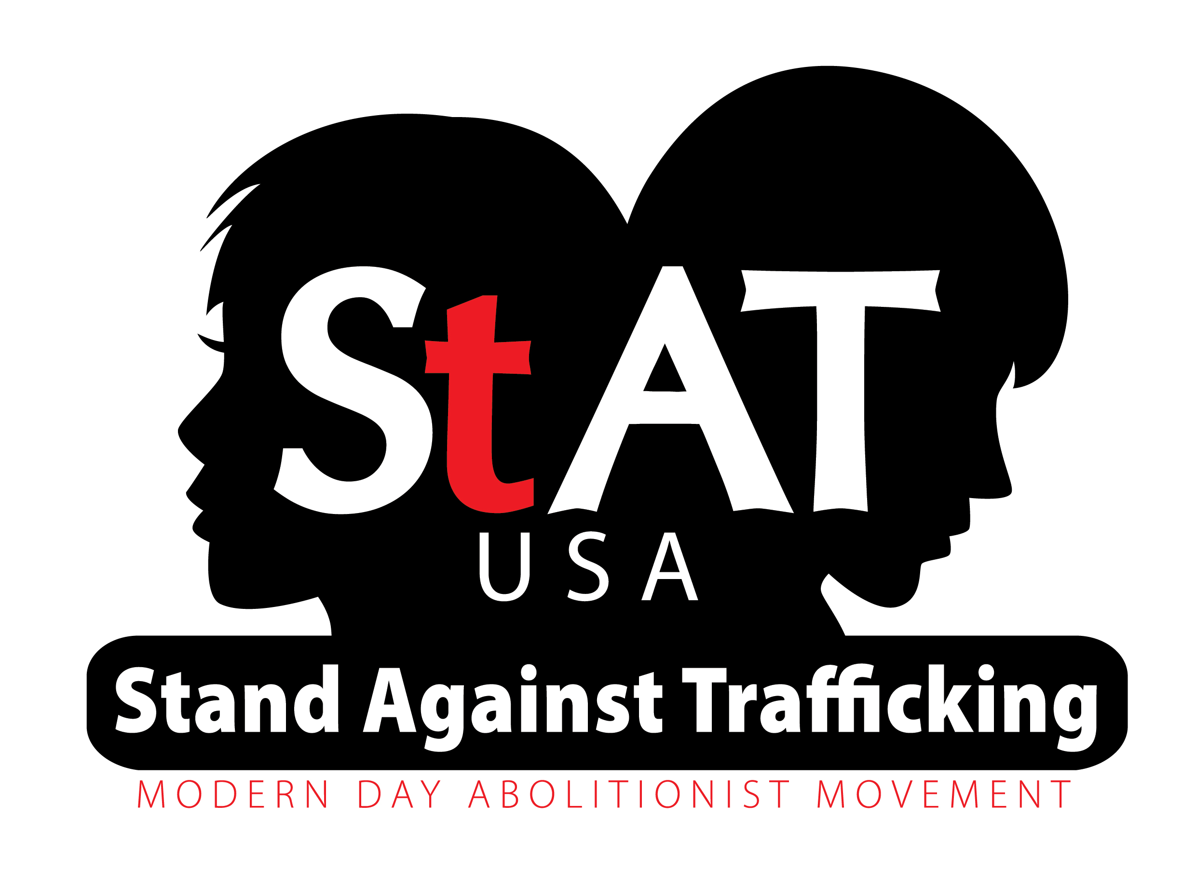

Community Resource Center

AWARENESS, PREVENTION, PROTECTION, IMPACT
A community Resource Center can be set up in any church or public building. A safe place to develop life skills, change cognitive behavior, build supportive relationships, and receive resources to create a healthy lifestyle.

The center will support the vulnerable in our community with a healthy perspective. Without community support, many will stay stuck in the system. It will also be a place for prevention and protection, so when “choices” seems gone, you can give a healthy viewpoint on life decisions.

The vulnerable in society today are hurting and looking for answers. We are determined to bridge those who want “change” to have the opportunity for those “changes.”

DISCOVER: As a community, we owe it to society to look “beneath” the surface, to “believe” we can make a difference, and to change someone’s life.

Training: Life Coaches, Storehouse clerk, teacher, prayer partner, financial partner, coordinators.

STOREHOUSE NEEDS: Backpack, Toilet paper, paper towels, cleaning products, new socks, underwear, sports bras, long and short sleeve t-shirts, sweat pants, (all sizes) feminine hygiene products, baby formula, diapers, wipes.

It is easy and convenient for all those who are compassionate for change.

